Development of control strategies for earthquake reproduction on uniaxial shaking table

Desenvolvimento de estratégias de controlo para reprodução de sismos em plataforma sísmica uniaxial

Afonso Costa Henrique^{1,2} | Miguel Ayala Botto³ | Fernando Pires de Oliveira¹
¹LNEC – Laboratório Nacional de Engenharia Civil, Portugal ²IST – Instituto Superior Técnico, Portugal ³IDMEC, Instituto Superior Técnico, Universidade de Lisboa, Lisboa, Portugal

Keywords: Earthquake Engineering, Control Systems, System Identification, Closed-loop Identification
Palavras-chave: Engenharia Sísmica, Controlo de Sistemas, Identificação de Sistemas, Identificação em Anel Fechado

Abstract
Despite computational models used in earthquake simulations becoming highly sophisticated and reliable, they still face limitations when complex, nonlinear, or poorly understood structural behaviours are considered. Moreover, numerical simulations, even with advanced methods, require experimental benchmarks to ensure accuracy, and machine learning approaches also rely on experimental data for training and updating models. Experimental testing provides critical validation and calibration for these models. In summary, earthquake experimental testing remains indispensable for model validation, understanding structural complex behaviours, and ensuring structural safety
This paper analyses control strategies for reproducing earthquake ground motion on the uniaxial shaking table located at Laboratório Nacional de Engenharia Civil, through a computational model of the system. The objective of the controller is to ensure the shaking table reproduces the target earthquake ground motion as accurately as possible., and it’s performance was evaluated, in terms of response spectra, under three distinct control strategies: the currently used method consisting on pseudo-open loop offline adaptive control with an iterative process of generating drive signals and running the tests in closed loop with a PI controller; a tuned PIDF controller (proportional, integral, and filtered derivative) ; and an optimal controller.
The results indicate that both the tuned PIDF and the optimal controllers offer superior performance in terms of response spectra compared to the iterative method, whereas the optimal controller performed best. The performance of the controllers depends on a reliable dynamic model identification of the uniaxial shaking table, and the sensitivity of each method to the quality of the identification requires further investigation.
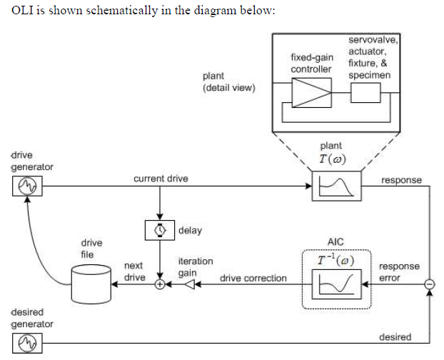

Introduction
The current shaking table earthquake reproduction process at LNEC consists on iteratively synthesizing a drive signal (figure 1), distinct from the target motion, such that the shaking table replicates the response spectra of the target, i.e. the earthquake ground motion.
Figure 1: Iterative drive signal generation method

At the end of each test, the system's performance is evaluated by comparing the response spectrum of the reference signal with that of the output signal measured on the platform. However, it is not always possible to achieve satisfactory performance with the command signal synthesized initially, and it may be necessary to generate more than one drive signal and carry out additional tests at the same amplitude (figure 2). This procedure, although necessary in some situations, should be avoided as it induces additional damage to the structure.

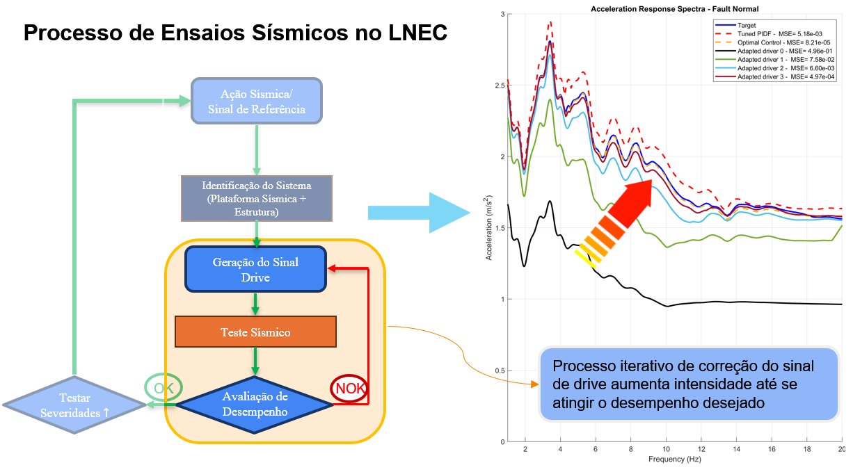
Figure 2: LNEC's test process. New driver signals are generated (loop highlighted in yellow box) till the shaking platform produces the desired response spectrum (plot on the right). Following this, the target severity is increased and the process is repeated.

Objectives
The objective of this work is to implement a controller, or strategy, to ensure that the shaking table reproduces the earthquake target signal as accurately as possible, and replace the iterative method if sufficient performance is obtained.

Control Strategies: Performance evaluation in simulation environment
Two controllers, a PIDF and an optimal controller, each tuned, following the system identification performed at the beginning of every severity test level, were evaluated as possible improvements to reproducing the earthquake ground motion on the shaking table (figure 3).

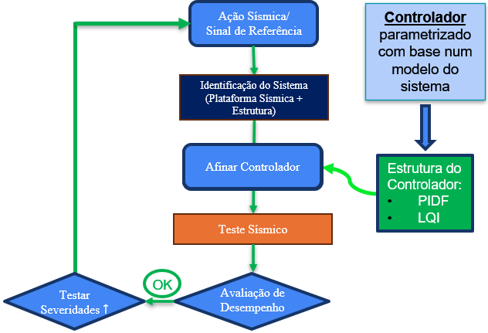
Conclusions
The results indicate that the proposed controllers offer superior performance in terms of response spectra compared to the iterative method, while also requiring less user intervention in the process, with the optimal control strategy providing the best results in every instance. The performance of the tuned controllers was found to outperform the iterative method even after three iterations, achieving satisfactory performance on the first run, which is highly desirable. However, the performance of each method relies on accurate system identification, and the sensitivity of each method to this factor requires further investigation.
Figure 3: Proposed test process with controller tunning at every severity level, and replacing iterative driver design entirely

